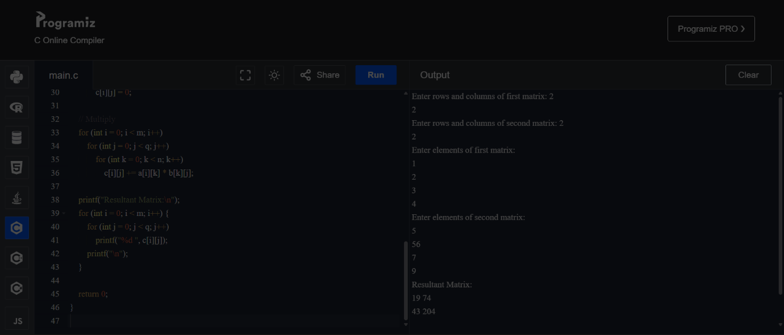

Code1: #include <stdio.h>

int main() {

int m, n, p, q;

printf("Enter rows and columns of first matrix: ");

scanf("%d %d", &m, &n);

printf("Enter rows and columns of second matrix: ");

scanf("%d %d", &p, &q);

if (n != p) {

printf("Matrix multiplication not possible!\n");

return 0;

}

int a[m][n], b[p][q], c[m][q];

printf("Enter elements of first matrix:\n");

for (int i = 0; i < m; i++)

for (int j = 0; j < n; j++)

scanf("%d", &a[i][j]);

printf("Enter elements of second matrix:\n");

for (int i = 0; i < p; i++)

for (int j = 0; j < q; j++)

scanf("%d", &b[i][j]);

// Initialize result matrix with 0

for (int i = 0; i < m; i++)

for (int j = 0; j < q; j++)

c[i][j] = 0;

// Multiply

for (int i = 0; i < m; i++)

for (int j = 0; j < q; j++)

for (int k = 0; k < n; k++)

c[i][j] += a[i][k] \* b[k][j];

printf("Resultant Matrix:\n");

for (int i = 0; i < m; i++) {

for (int j = 0; j < q; j++)

printf("%d ", c[i][j]);

printf("\n");

}

return 0;

}